# **Fuzzy Inference System**

Krishna Kumar Veeraputhiran

Grand Canyon University

DSC 540 – O500 – Machine Learning for Data Science

Dr. Aiman Darwiche

September 15,2021

# **Fuzzy Inference System**

The given problem has two inputs namely x and y and the corresponding output being z. In this report we will build a Fuzzy Inference System which will take the inputs x and y and using the fuzzy model built will give the output value z. We will see step by step explanation of this Fuzzy inference system in this report.

**Problem Statement**

For our Fuzzy inference system we need to find the output variable z for the corresponding x and y. The fuzzy operations that would be applied on the inputs are min and max.

**Fuzzy Sets**

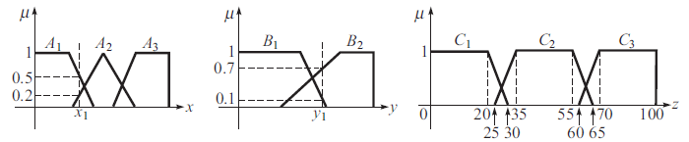

The above picture depicts the different fuzzy sets for our input variables and the output variable. The fuzzy set for x1 are A1, A2 and A3. The parameter A1 and A3 takes a trapezoidal membership function while A2 takes a triangular membership function. The fuzzy variable y1 is represented by two trapezoidal membership function B1 and B2. The output variable z has three trapezoidal membership function represented by C1, C2 and C3.

**Fuzzy Rules**

The three rules that we in hand for FIS are, a) If x is A3 or y is B1 then z is C1 b) If x is A2 and y is B2 then z is C2 c) If x is A1 then z is C3.

**Fuzzification & Evaluation**

From the diagram above we can see that the inputs are fuzzified. They can be given as,

μ (xA1) = 0.5 ; μ (xA2) = 0.2; μ (yB2) = 0.7 & μ (xB1) = 0.1. These fuzzified inputs need to be applied to the antecedents of the fuzzy rules. The degree of fulfilment of the fired rules can be given as below.

For Rule 1, α (1) = max(μ (xA3), μ (xB1)). Here μ (xA3) =0.0 (based on the inputs provided) and μ (xB1)= 0.1. Also it is to be noted we are using the max function as this rule uses an OR condition. Hence α (1) = max(0.0, 0.1) => 0.1, which is our C1. This can be plotted like shown below.

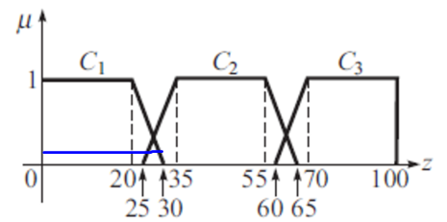

For Rule 2, α (2) = min(μ (xA2), μ (yB2)). Here μ (xA2) = 0.2 and μ (yB2) = 0.7. We will be the using the min function here as the Rule uses an AND condition. Hence α (2) = min(0.2 , 0.7) = 0.2. This is the outcome for the C2 and can be plotted as below,

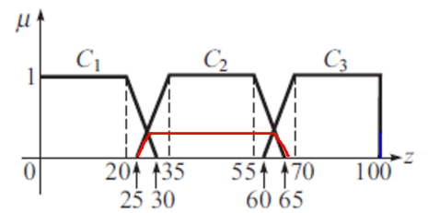

Finally Rule 3 can be , α (3) = μ (xA1) = 0.5. This is the outcome for C3 and can be plotted as,

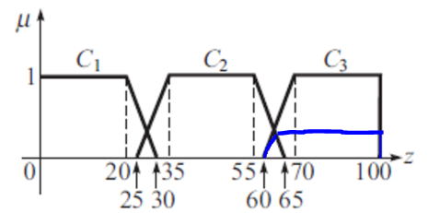

# **References**

Gopal, M. (2019). *Applied machine learning*. McGraw-Hill Education.